*Muthurangam Government arts and science college,vellore-2.*

*Vechicle managementsystem using salesforce*

Project sumitted by:-

**Team Leader :** GUNASUNDARI.D

**Team member :** S.GAYATHRI

**Team member :** MONISHA .D

**Team member :** A.Nandhini

**Team member :** Nivetha s

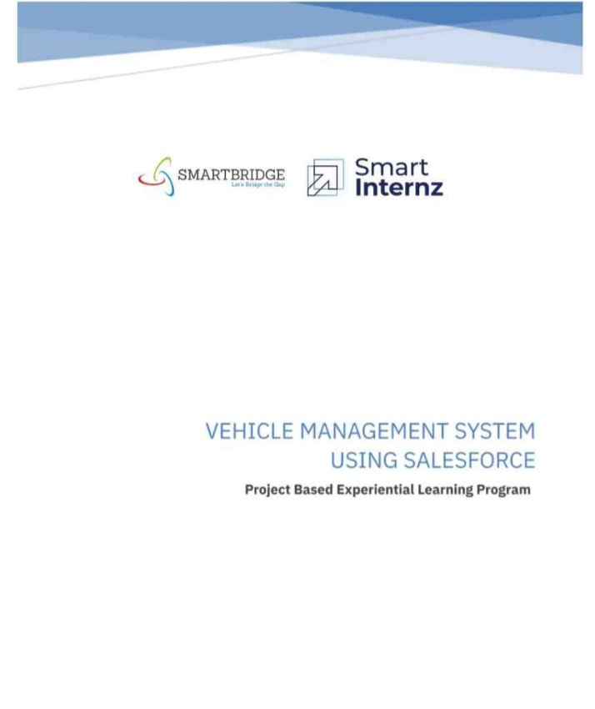

Content:Milestone 1:-

creating developer account.

Milestone 2:-

* To create a object.
* To create driver object.

Milestone 3:-

* creation of fields.
* fields in driver object .

Milestone 4:-

*creation of vechicle management construction app.

Milestone 5:-

*create vechicle management profile and set its object permission.

Milestone 6:-

*create a user.

Milestone 7:-

*Reports and dashboards. *Dashboards

# Milestone 1:-

oGo to developer org in salesforce. oClick on sign up. oEnter the following details on the sign up form. oClick on sign up after filling these

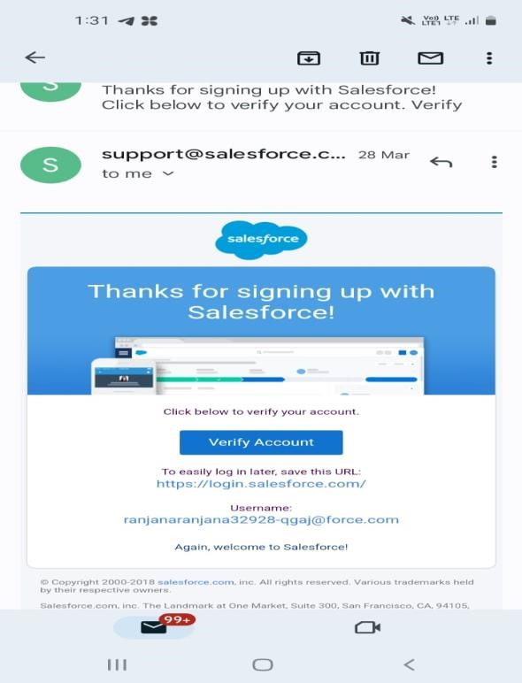**Account activation** :-

[click on verify to verify your account]

→

Login to salesforce account

* Go to ***salesforce.com*** and click on login.

figure2:

-

figure3:

-

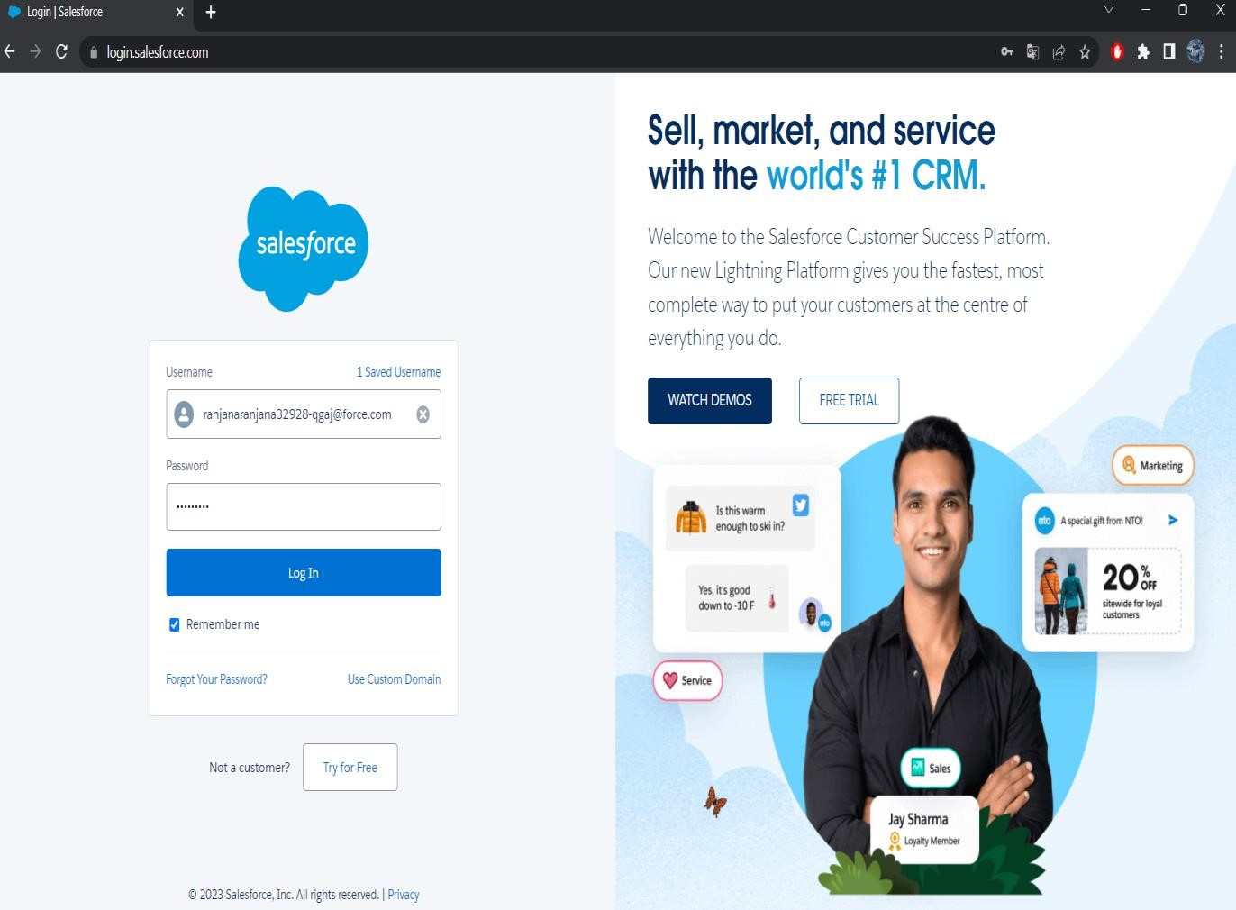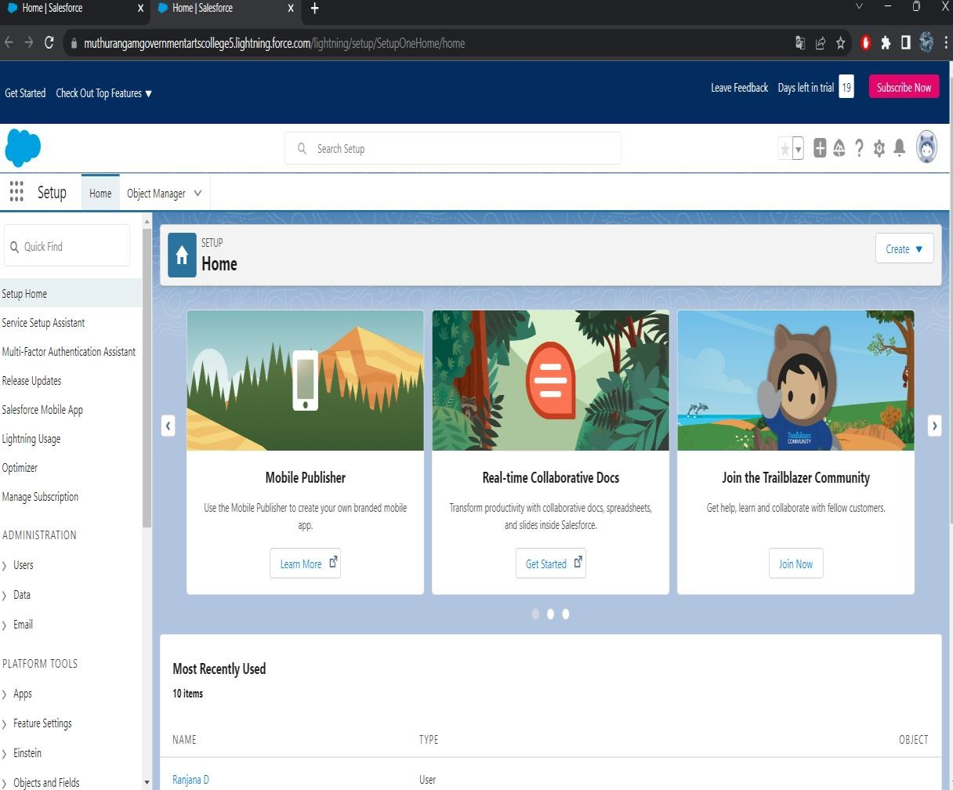

* Enter the user name password that you just created.
* After login this is the home page which you will see.

Milestone2:-

* To create an object:-
* 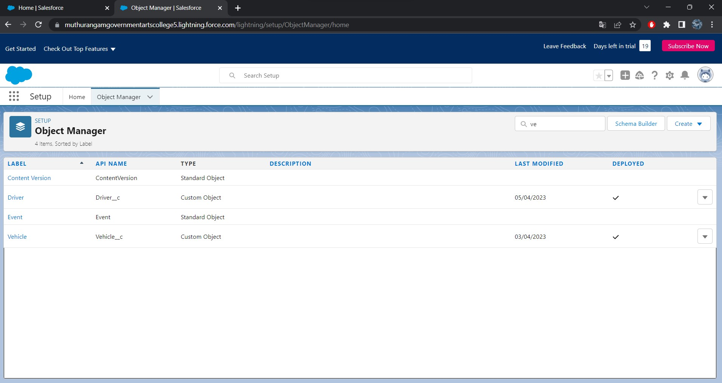For vehicle management we need to create 2 object ; vehicle , Driver.
* Create an object ,as vehicle and driver on the custom object definition page

Figure 4:-

Milestone 3:-

• Creating fields in objects:-

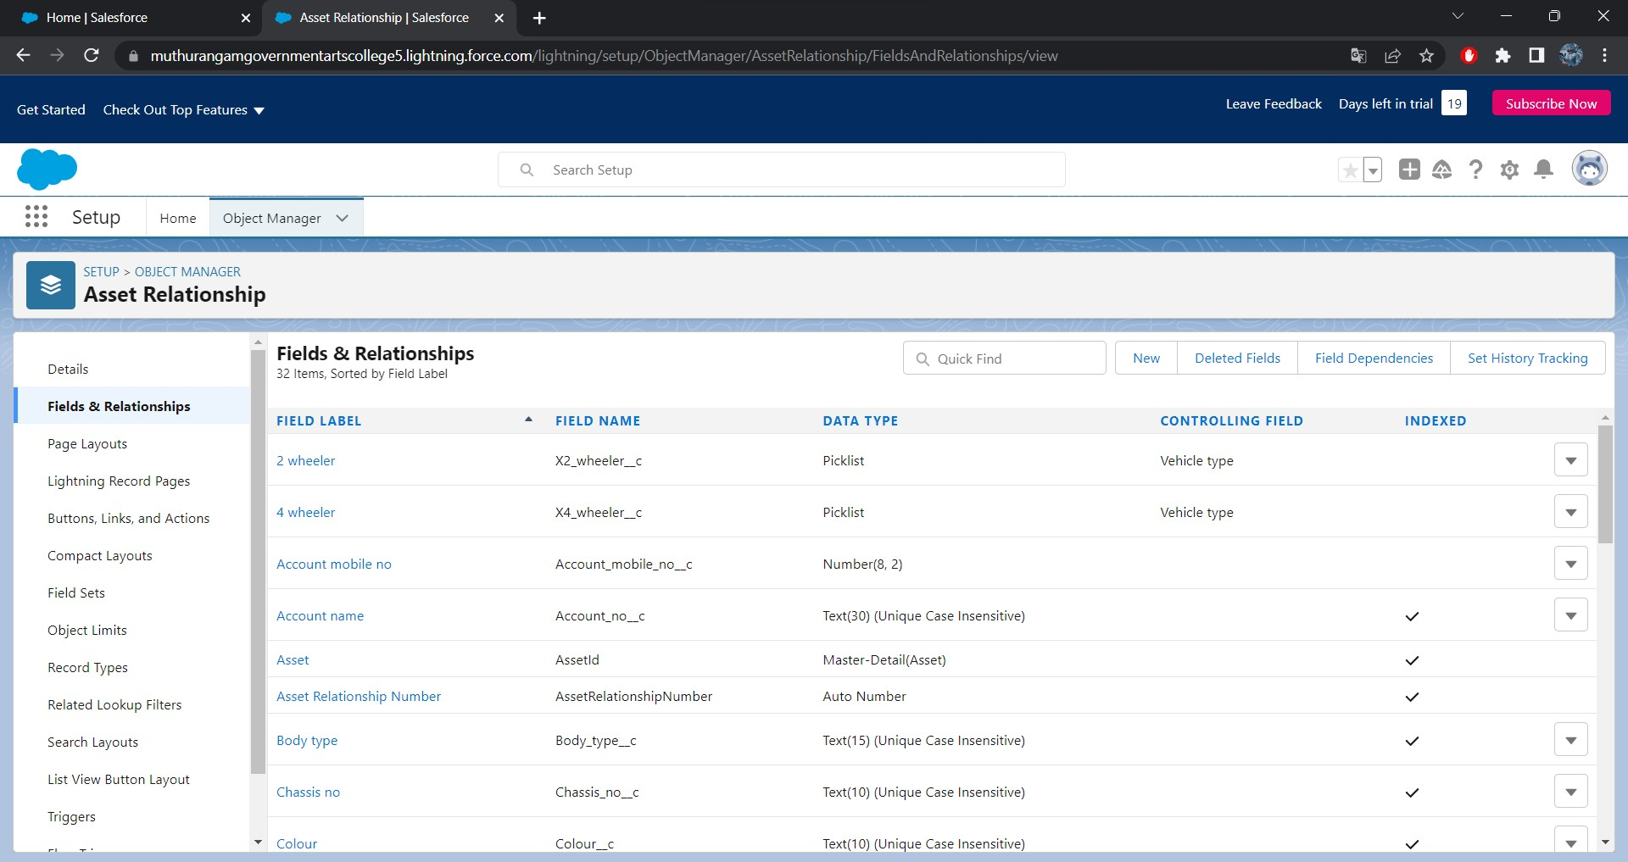(now click field & realtionship New

Fill in the field label name  Next  Next save)

Figure4:-

## *Fields in driver*:-

* Create dependency between two picklist so that when vehicle type is selected, 2 wheeler brands available in

2 wheeler field

* 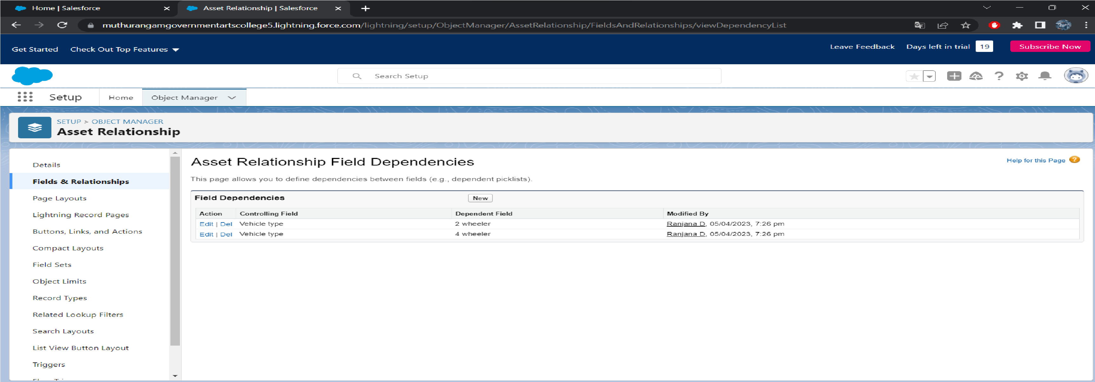In field &relationship click field dependencies.
* select vehicle type as the controlling field 7select 2 wheeler as dependent field .
* Select appropriate 2 wheeler brands.
* Follow same steps for 4 wheeler also
* Figure 5:-

Milestone4:-

• Lightning app:-

### ➢ Create vehicle management construction app

* Click new lightning app. Enter vehicle management as the app name App click next utility click next

Figure6:

-

figure 7:

-

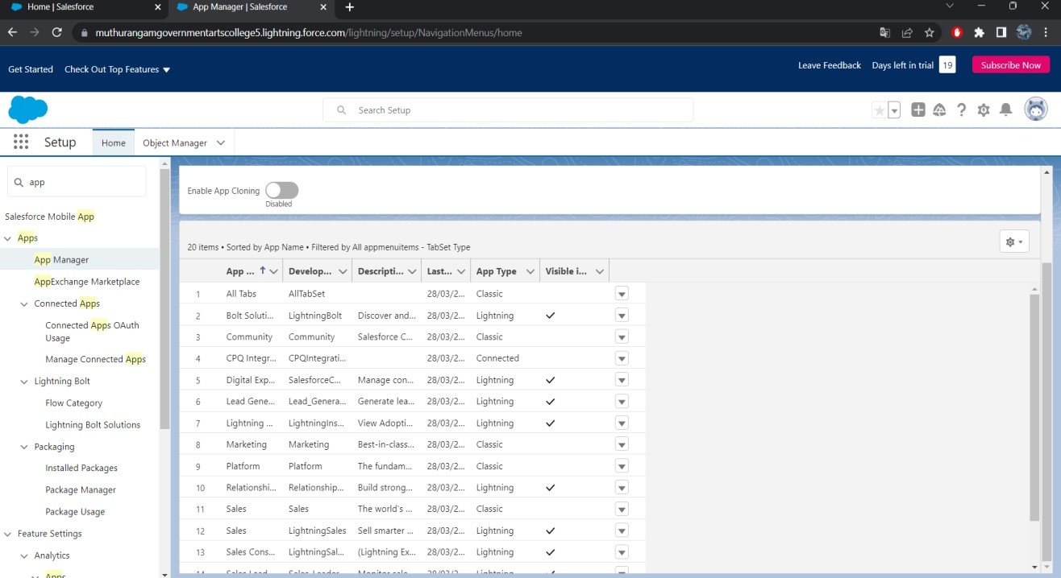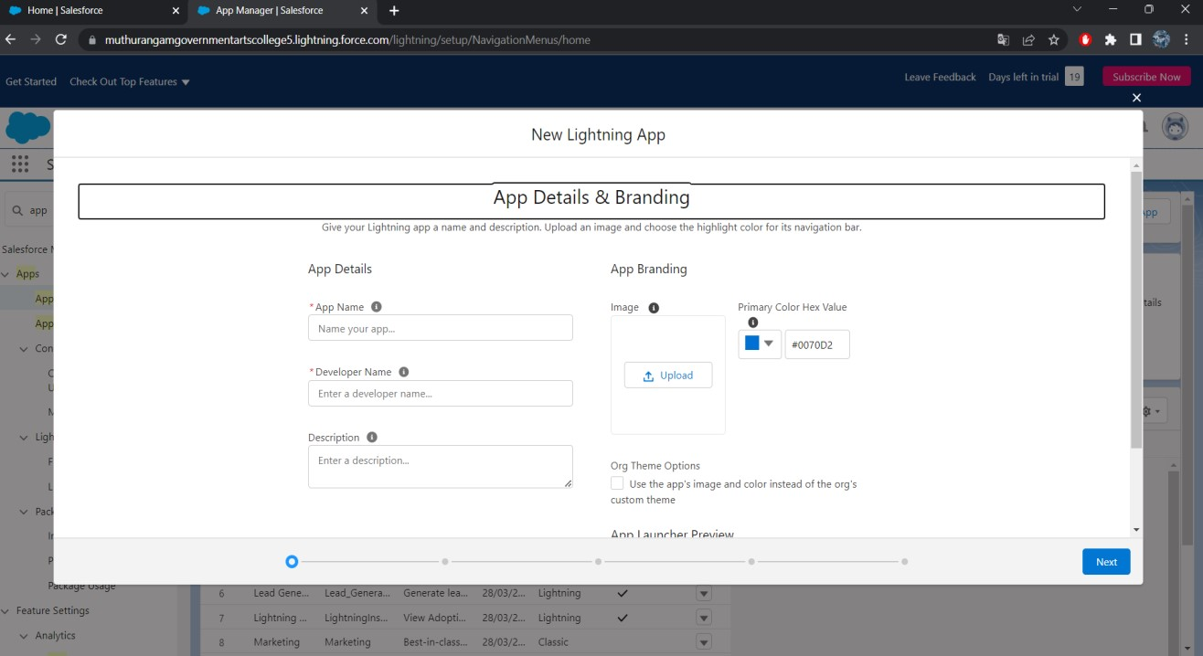

* Available items, select accounts, contacts, oppurtunities, vehicle, driver, reports and dashboards
* profiles – system administer click and save and finish

Milestone5:-

▪ Profile:-

To create new profile :-

Figure8:

-

figure9:

-

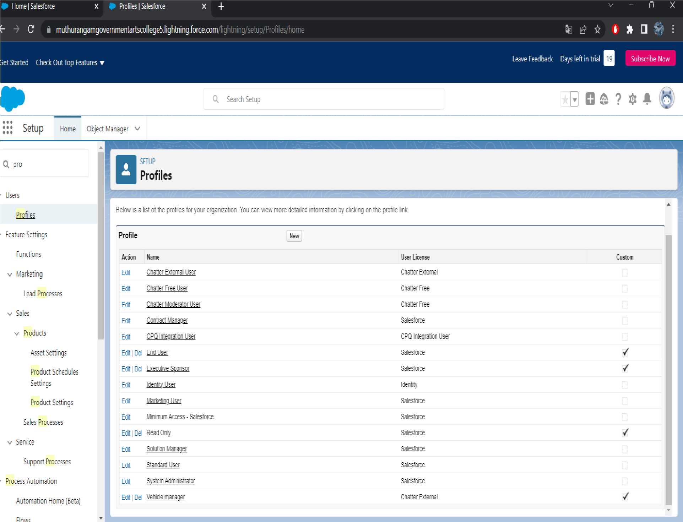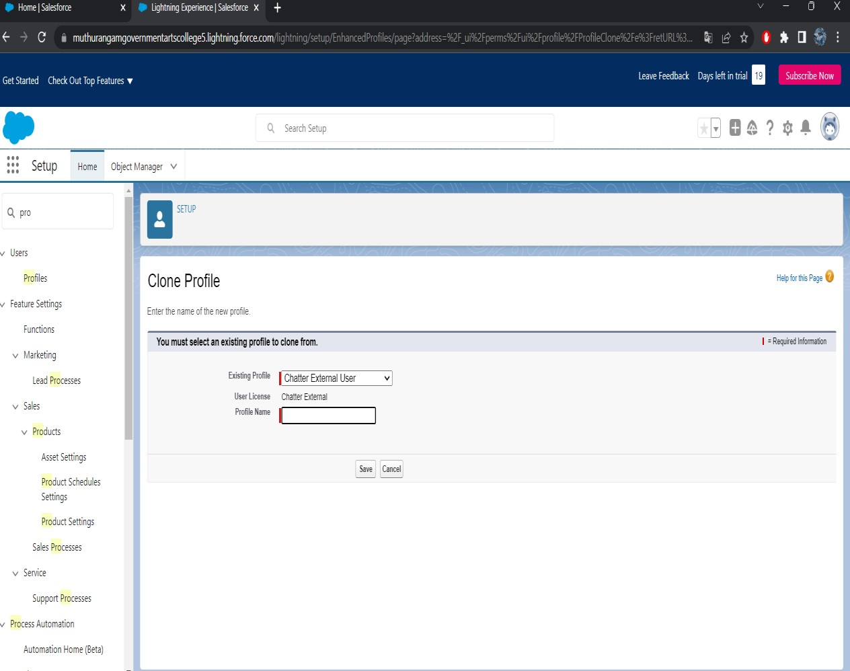

Go to setup  type profile in quick final box click on profiles clone the desired profile enter profile name  save

Figure 10:-

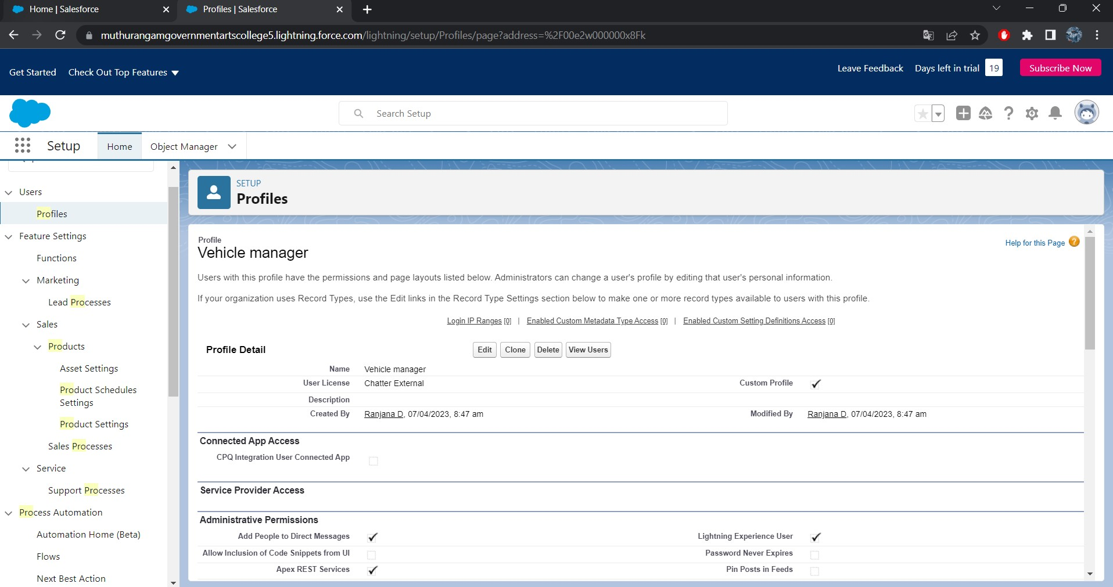

Set up roles

:

-

•

Set up

Roles

setup Roles

expand all

•

Fill up label as vehicle manager, Role name vehicle

manager

•

Create two operator 1 and 2 under vehicle manager

figure 11:

-

figure 12:

-

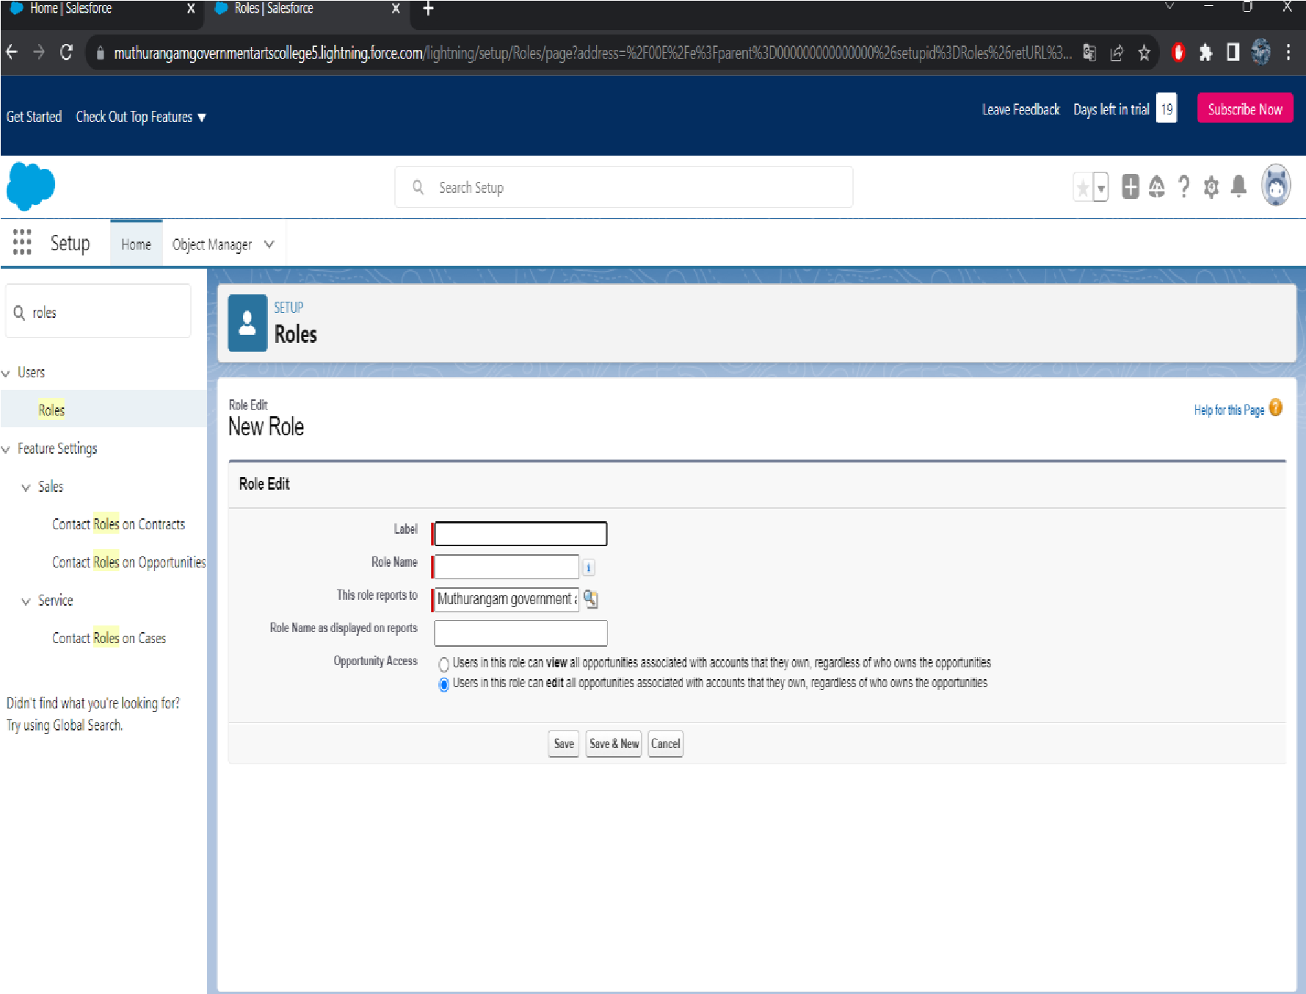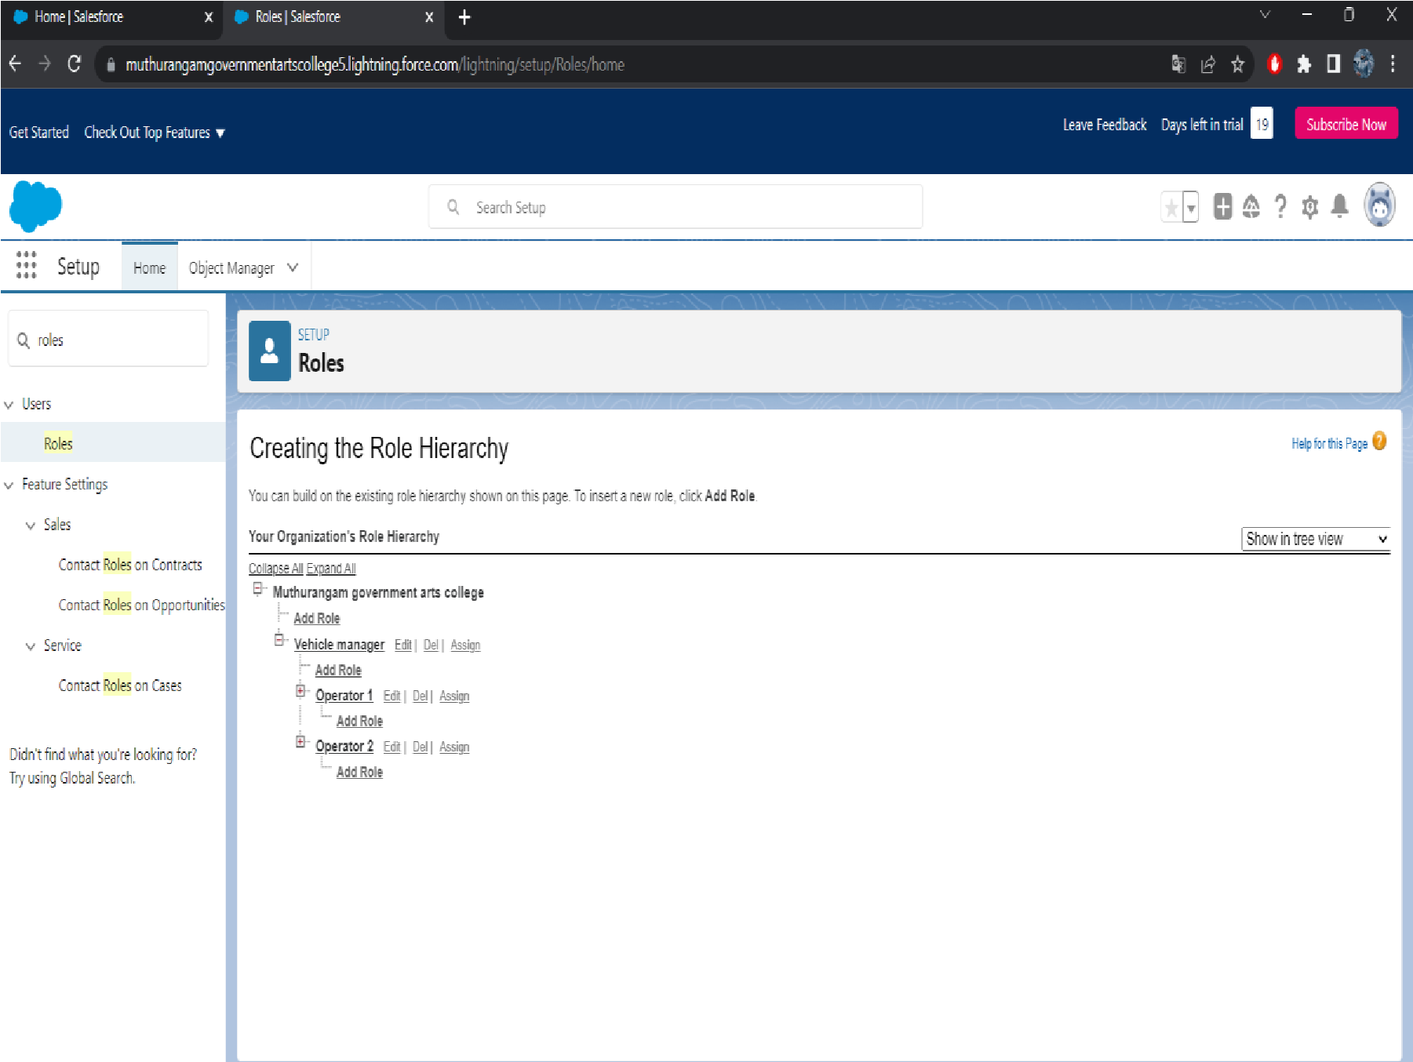

Milestone 6:-

• In user

* Select role as vehicle manager
* 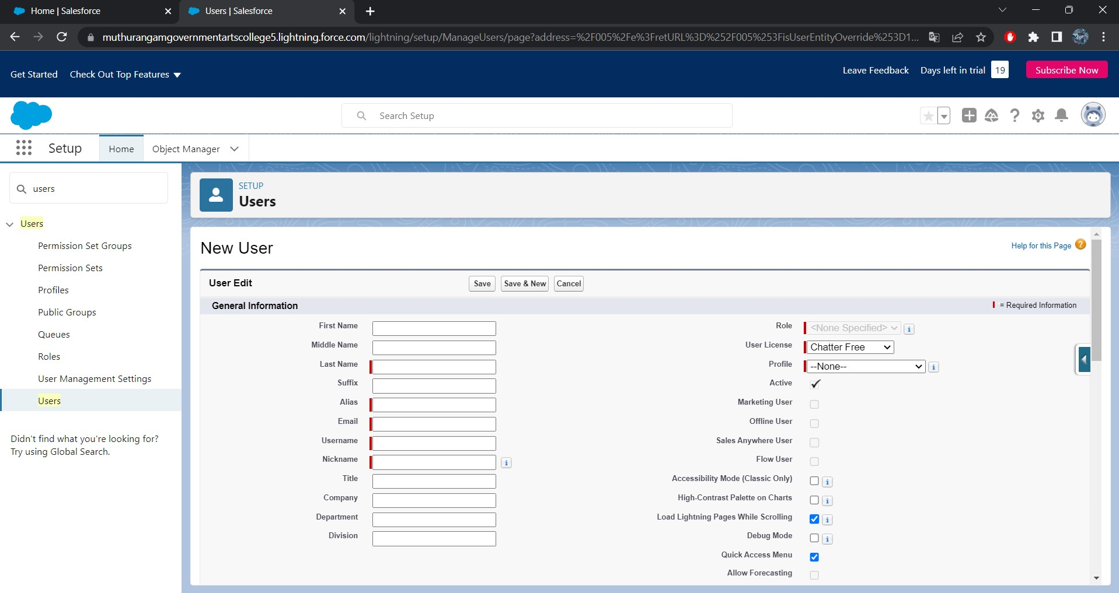User license as salesforce
* Profile as vehicle manager

➢ Also similar for operator 1 and operator 2

Figure 13:-

Milestone 7:➢Reports:

•Go to report click  New report

•

Click save

figure 14:

-

figure 15:

-

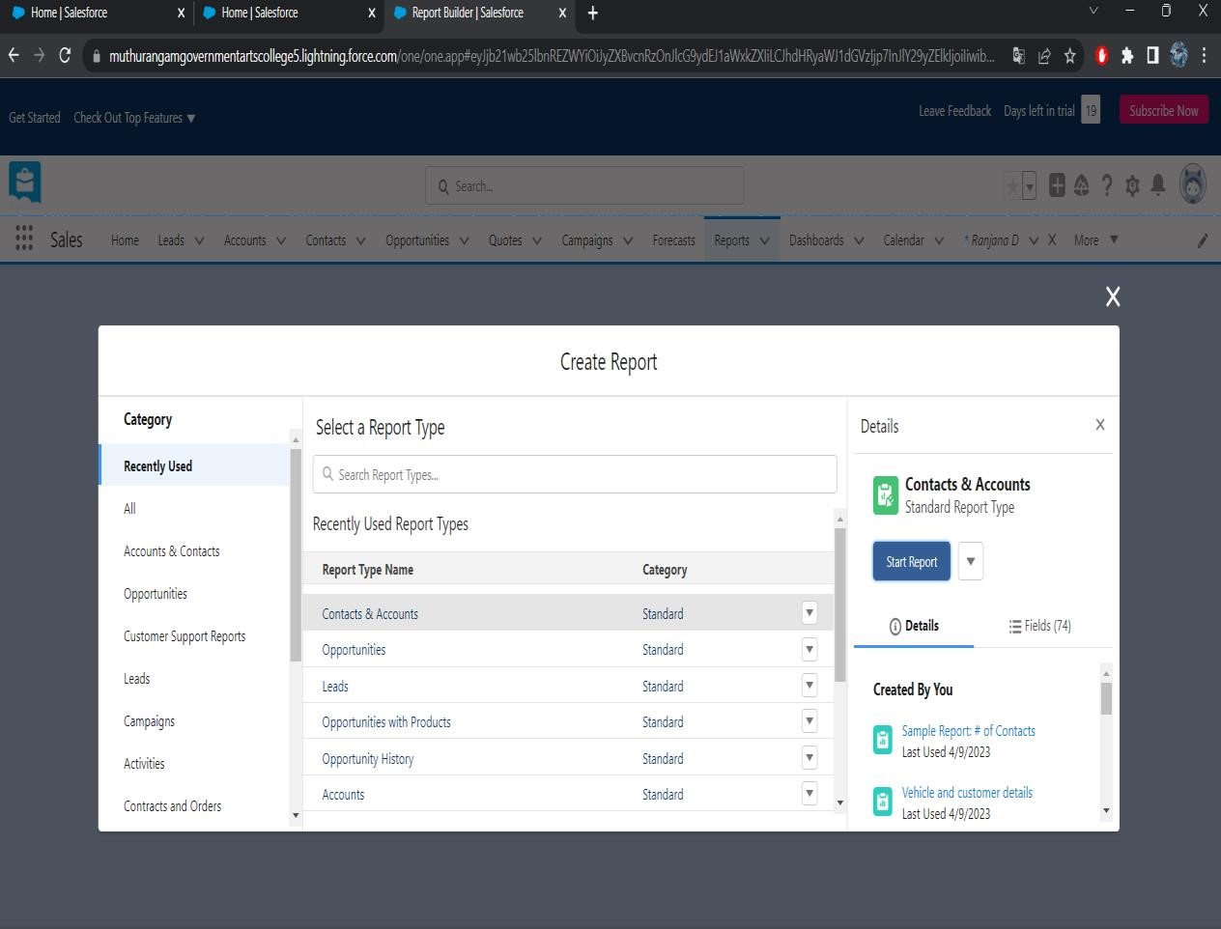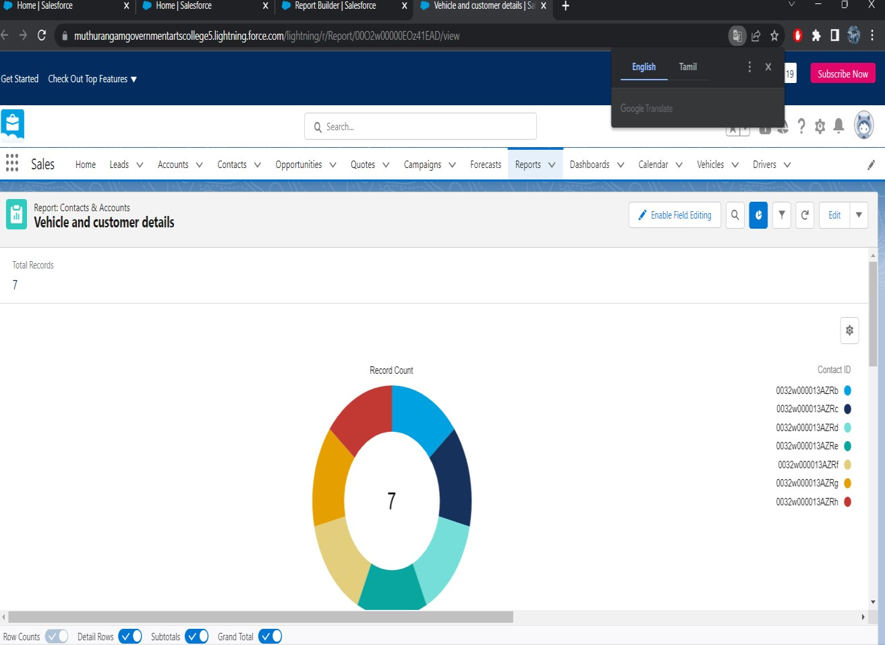

•click filters  select filters

•add columns add vehicle

### Dashboard :-

* Click the dashboars tab
* Click new dashboards
* Name the dashboards vehicle and customer detail
* 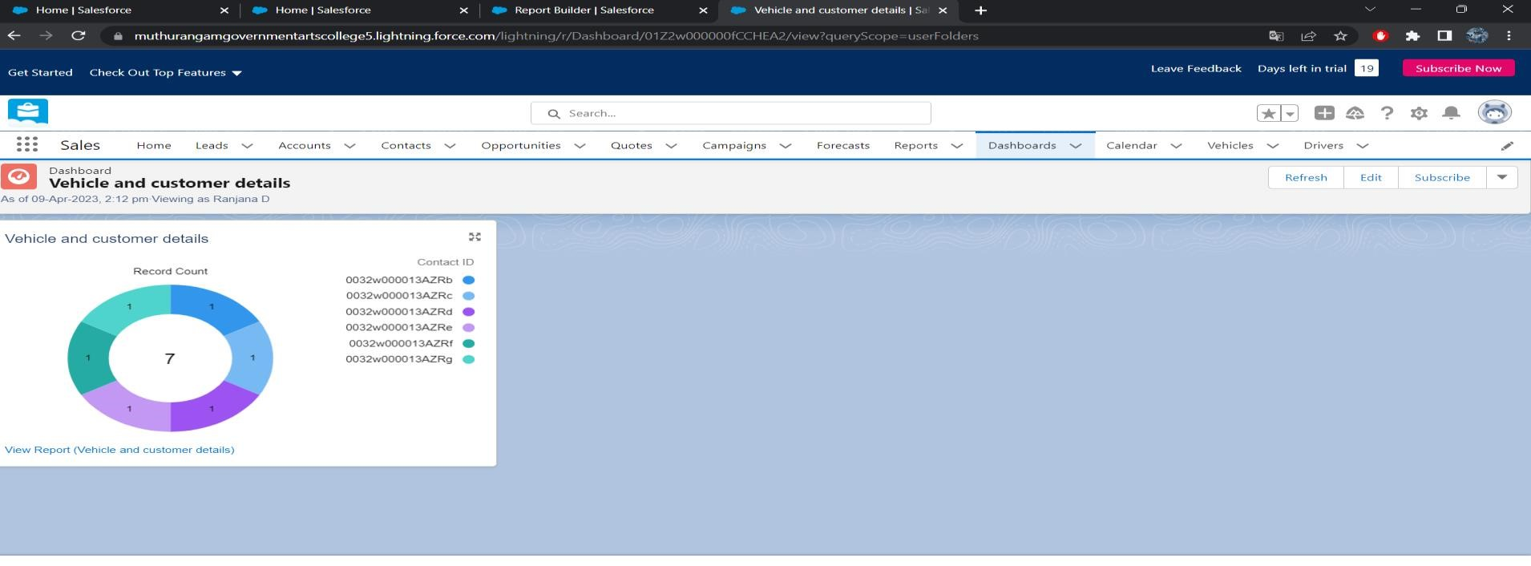Click  click+component
* Select the supplies report and click select
* Vertile bar chart component and click add
* Click save

Figure 16:-

**Thanks**

# THE END

OUR SINCERE GRATITUDE TO

*SALESFORCE

*SMARTBRIDGE(SMART

## INTERNZ)